Vidyavardhini’s College of Engineering & Technology



Department of Artificial Intelligence and Data Science (AI&DS)

|  |  |
| --- | --- |
| **Name:** | Vinith Shetty |
| **Roll No:** | 55 |
| **Class/Sem:** | SE/IV |
| **Experiment No.:** | 9 |
| **Title:** | Program for interfacing 8086 with 8255 PPI. |
| **Date of Performance:** | 26/03/2024 |
| **Date of Submission:** | 02/04/2024 |
| **Marks:** |  |
| **Sign of Faculty:** |  |

Vidyavardhini’s College of Engineering & Technology



Department of Artificial Intelligence and Data Science (AI&DS)

**Aim:** 8255 is configured in mode O is simple Inuput / Output Mode. Ports A,B,C are in mode 0. All the posts are in output mode and data is transmitted to the respective ports.

**Apparatus :** Microprocessor 8086 and 8255 PPI experimental setup kit

**Theory:**

The programmable Peripheral Interface chip 8255 has three 8-bit Input / Output ports i.e. Port A, Port B, Port C upper (PCU) and Port C lower (PCL). Direct bit set/reset capability is available for port C. 8255 is a very powerful tool for interfacing peripheral equipment to the microprocessor. It is flexible enough to interface with any I/o device without the need of external logic.

**Procedure :**

1. Connect 8086 kit to 8255 PPI kit using 50 pin FRU cable.
2. Default I/O address ranges are :

SELECTION ADDRESS

Port A 30 H

Port B 31 H

Port C 32 H

Command Port 33 H

1. 80 H is the control word for 8255. It is set in simple I/O mode and all the ports are in output mode 0

|  |  |  |  |  |  |  |  |
| --- | --- | --- | --- | --- | --- | --- | --- |
| **D7** | **D6** | **D5** | **D4** | **D3** | **D2** | **D1** | **D0** |
| 1 | 0 | 0 | 0 | 0 | 0 | 0 | 0 |

Always 1 Group A Port A Port C1 Group B Port B Port C2 for I/O mode 0 (output) (output) (output) (output) (output)

1. The LED’s connected to the pins at Port A glow according to the data transmitted on port A. 5. The LED’s connected to the pins of port B glow according to the data transmitted on Port B.

6. The LED’s connected to the pins of port C glow according to the data transmitted on Port C.

Vidyavardhini’s College of Engineering & Technology



Department of Artificial Intelligence and Data Science (AI&DS)

**Program :**PPI Program:

MOV AL, 80

OUT 33, AL

MOV AL, 02

OUT 30, AL

MOV AL, 03

OUT 31, AL

MOV AL, 04

OUT 32, AL

INT 3

**Output:**

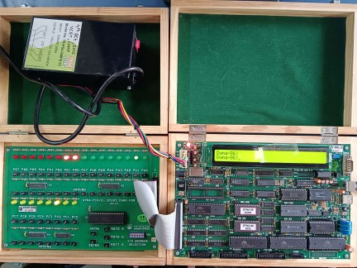

Vidyavardhini’s College of Engineering & Technology



Department of Artificial Intelligence and Data Science (AI&DS)

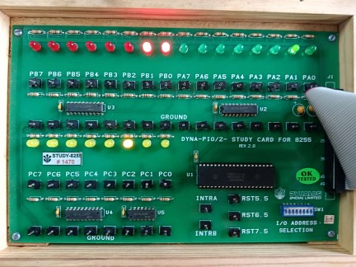

Vidyavardhini’s College of Engineering & Technology



Department of Artificial Intelligence and Data Science (AI&DS)

Segment : C000 Offset : C000

|  |  |  |  |
| --- | --- | --- | --- |
| **Memory** | **Opcode** | **Instructions** | **Comments** |
| C000 | B0 | MOV AL,80H | Mode 0, All ports in output mode |
| C001 | 80 |  |  |
| C002 | E6 | OUT CWR, AL |  |
| C003 | 33 |  |  |
| C004 | B0 | MOV AL, 55H | Data for Port A |
| C005 | 55 |  |  |
| C006 | E6 | OUT PORT A,AL |  |
| C007 | 30 |  |  |
| C008 | B0 | MOV AL,AAH | Data for port B |
| C009 | AA |  |  |
| C00A | E6 | OUT PORT B,AL |  |
| C00B | 31 |  |  |
| C00C | B0 | MOV AL,0FH | Data for port C |
| C00D | 0F |  |  |
| C00E | E6 | OUT PORTC,AL |  |
| C00F | 32 |  |  |
| C010 | CC | INT 3 | Stop |

Vidyavardhini’s College of Engineering & Technology



Department of Artificial Intelligence and Data Science (AI&DS)

**Conclusion :**

1. Explain the modes of 8255.
2. Explain the format of control word of 8255 PIC

Answer:-

1) The 8255 microprocessor has three operating modes:

Mode 0

The basic input/output mode. In this mode, each of the three ports (Port A, Port B, and Port C) can be configured individually as input or output.

Mode 1

The strobed input/output mode. In this mode, either port A or port B can work as simple input or output port, and port C bits are used for handshake signals.

Mode 2

The third operating mode. In this mode, only port A works, and port B can work either in mode 0 or mode

2. The 8255 is a programmable peripheral interface (PPI) chip that can be used to interface a microprocessor with various peripheral devices. The control word is an 8-bit word that is used to configure the 8255. The format of the control word is as follows:

Bit 7: Mode select bit

Bit 6: Mode select bit

Bit 5: Mode select bit

Bit 4: Port C bit set/reset bit

Bit 3: Port B bit set/reset bit

Bit 2: Port A bit set/reset bit

Bit 1: Interrupt enable bit

Bit 0: Interrupt mask bit

The mode select bits are used to select one of the three operating modes of the 8255:

Mode 0: Simple I/O mode, Mode 1: Handshake I/O mode, and Mode 2: Bit set/reset mode.

The port C bit set/reset bit is used to set or reset the corresponding bit in port C. The port B bit set/reset bit is used to set or reset the corresponding bit in port B. The port A bit set/reset bit is used to set or reset the corresponding bit in port A.

The interrupt enable bit is used to enable or disable interrupts from the 8255. The interrupt mask bit is used to mask interrupts from the 8255.

The following table shows the different combinations of the mode select bits and the corresponding operating mode:

Vidyavardhini’s College of Engineering & Technology



Department of Artificial Intelligence and Data Science (AI&DS)

Mode select bits

Operating mode

000

Mode 0: Simple I/O mode

001

Mode 1: Handshake I/O mode

010

Mode 2: Bit set/reset mode

011

Reserved

100

Reserved

101

Reserved

110

Reserved

111

Reserved

The following example shows how to configure the 8255 to operate in mode 0 with port A as an output port and port B as an input port:

Control word: 00000000

The following example shows how to configure the 8255 to operate in mode 1 with port A as an input port and port B as an output port:

Control word: 00000001

The following example shows how to configure the 8255 to operate in mode 2 with port C as an output port:

Control word: 00000010